

2022-2023
HANDBOOK

You have been taught the Holy Scriptures from childhood,
and they have given you the wisdom to receive the salvation
that comes by trusting in Christ Jesus.
2 Timothy 3:15

1085 Scott Dr Prescott, AZ 86301 928-778-7049

STATEMENT OF PURPOSE
The purpose of American Lutheran School is to assist children in their spiritual, social, emotional, cognitive, and physical development in the context of a loving and enriching environment that is intentionally Christ-centered. Our program provides a variety of learning experiences. We allow the child to explore his/her environment with guidance by participating in activities in which they can experience success and spiritual growth.

SERVICES OFFERED
American Lutheran School is a non-profit organization. It is a ministry of American Lutheran Church. The Bible is the spiritual basis of our program. Any child may attend the school, regardless of race, color, religion, or creed.

The school is dedicated to meeting the special needs of every child, including the needs of children with developmental and/or physical disabilities.

We offer a 2- or 3-day program for 3-5-year old’s and a 5-day pre-K program for 4 and 5 year olds who will attend kindergarten the following school year. In addition, we offer early morning and lunch care daily, 8:00 am to 8:30 am and 11:30 am to 1:00 pm. A minimal fee is charged.

Children must be 3 years old by August 31st and toilet-trained before they enroll. Children are expected to be able to use the bathroom and dress independently.

This facility is regulated by the Arizona Department of Health Services; 150 N. 18th Ave., Suite 400, Phoenix, AZ 85007. 602-364-2539. We are licensed to serve 59 preschool children daily. Facility inspection reports are available for viewing.

SCHOOL STAFF
All our staff have a professed belief in Jesus Christ as their personal Lord and Savior and have the education and experience required by the State of Arizona. They receive a salary and attend regular staff meetings, in-service training, workshops, and classes to learn new skills in the art of teaching young children.

Our staff members are: Director Lori Barbe
2-day Teacher Jennifer Garber
3-day Teachers Sarah Snyder, Breanna Hall
Pre-K Teachers Darcel DuBord, Charity Huard
Teacher's Aide Stacia Strom-DuBord, Ashley Rhodes

GOVERNANCE
The school is governed by the American Lutheran School Board. Its purpose is to oversee the general operation of the school and support the staff in their efforts.

ADMISSION REQUIREMENTS
Each child must be enrolled by his/her parent or guardian. An "Emergency Information and Immunization Record Card" must be completed and signed by the parent or guardian at the time of enrollment. Special needs or requirements shall be clearly defined in writing. Parents will present a copy of the child's birth certificate and immunization record at the time of enrollment. If the child is being reared in a religion that opposes immunization, a signed affidavit is required of the parent or guardian stating the fact. Evidence of legal custody is required if applicable. American Lutheran School reserves the right to refuse admission to or withdraw a student at any time. A $60 non-refundable registration fee shall be paid at the time of registration.

INSURANCE
Our school carries liability and accident insurance to meet the standards set by the Arizona Department of Health Services. Documentation of liability insurance is available in the church office. Please contact the director for information regarding claims.
MEDICATION
The staff will not administer medication to a child without authorization from the child's physician, parent or guardian that contains the following information:

- The name of the child.
- The name and prescription number of the medication to be given.
- Specific instructions including the dosage date and times the medication is to be given.
- Reason the medication is being given.
- Signature of the parent or guardian.
- Date of authorization.

MEDICAL EMERGENCY PROCEDURES
In case of a medical emergency, the personnel in the office will contact the parent and make them aware of the emergency. If the emergency requires, 911 will be called and the child will be taken to the emergency room at Yavapai Regional Medical Center, 1003 Willow Creek Road.

PESTICIDE APPLICATIONS
The church and school utilize a professional exterminating company to keep our school safe and free from pests. There will be a posting at the sign in area at least 48 hours prior to pesticide application. All records of pesticide applications are kept on file in the preschool and church offices for your review.

SUN SAFETY POLICY
We are committed to your children’s health and protecting them from the sun’s rays during outdoor activities. In keeping with this philosophy, our facility will:
Ask you to apply sunscreen prior to arriving to school each day. Ask you to provide a hat, sunglasses, and/or long sleeve clothing for your child to put on when outdoors. Provide shade during outdoor activities. Limit outdoor activities that would involve direct sun exposure to skin between the hours of 10 a.m. and 4 p.m., when the UV rays are at the highest level by utilizing shaded outdoor areas and by protecting skin with clothing, hats, sunscreen and lip balm. Please see the preschool office for a sunscreen application permission slip if you would like us to apply sunscreen that you supply.

NON-SMOKING CAMPUS
American Lutheran School is a smoke free campus. There is absolutely no smoking in the facility or on the grounds during school hours or special events. ASHLine education materials are available to all families through the preschool office.

SECURE CAMPUS
Entrance to the church parking lot is ONE WAY. Please enter and drive to the right, circling the building to park in the school parking lot. This is for the safety of all families. Entrance and exit to the school is only available through the front door. The playground door is not to be used during school hours to enter or leave the building. All doors to our school are locked except during designated drop off or pick up times for families. If you are arriving late, picking up early, or needing in the school during locked times please use the bell outside the front entrance and a staff member will let you in. This is for your student’s safety. As always, parents have access to their child’s classroom, chapel area and playground when their child is in attendance.

SAFETY DRILLS
We will be practicing ways to stay safe at school. This includes fire and lockdown (QUIET) drills monthly. We follow the same protocols as other schools, businesses, and churches in the area. We work directly with our security team and the Prescott police department on all procedures to ensure our students safety. Families will not be granted access into the building during a drill. There will be signs on the doors, so you know when a drill is in process. If you are on campus during a drill, please follow all directions by the staff. You will receive an informational email after any lockdown drills.

HOURS OF OPERATION

Preschool Hours 8:30 to 11:30 AM
Early Bird 8:00 to 8:30 AM
Lunch Bunch 11:30 AM to 1:00 PM
Check monthly calendar for days when "Lunch Bunch" may not be available.

ARRIVAL/DISMISSAL
Preschool classes begin PROMPTLY at 8:30 AM and will be dismissed at 11:30 AM.
You may register for our Early Bird program if you need to bring your student prior to 8:30 am.
Plan to arrive at 11:25 AM to pick up your child so that you have adequate time to sign him/her "out”.

DAILY SIGN IN/OUT PROCEDURE
A parent or other adult must accompany each child into school and sign in and out on the check in computer or attendance register each school day. This may only be done by a person authorized to do so on the Identification and Emergency Information Card. The director will give each authorized person a registration code to register a fingerprint or PIN number. Please register in the office when someone new will be picking up your child. We are required to ask all persons other than parents or guardians (or known faces) to present picture identification to the staff.

EARLY BIRD AND LUNCH BUNCH
Extended care program allows children to stay for playtime/lunch on a per day basis.

Early Bird $5.00 per day
Please purchase "Early Bird" tickets at the preschool office for $5 each ($60.00 for a sheet of twelve tickets).
The fee is $5 for "Early Bird" care even if your child uses less than the allotted time because our staff is available from 8-8:30 am. Please add your child's name to the "Early Bird" roster when you bring your child in the morning.
8:00 – 8:30 am

11:30 – 1:00 pm
Lunch Bunch $10.00 per day
Please provide a sack lunch and drink with your child's name on it and put it in the bin outside the kitchen area. Please be sure to pack items that your child can manage. We DO NOT heat up lunches. Please write your child's name on the "Lunch Bunch" list at the sign in/out counter in the morning. You may purchase "Lunch Bunch" tickets in advance at the preschool office for $10 each ($120.00 for a sheet of twelve tickets). Tickets cost $10 even if you pick up your child early.
Lunch Bunch Registration closes at 9:30 am each day.

CHECK SCHOOL CALENDAR AND NEWSLETTERS FOR NO "LUNCH BUNCH" DAYS
THE PRESCHOOL PROGRAM
The preschool program is designed to provide experiences and activities that will fulfill each child's basic spiritual, emotional, psychological, intellectual, and physical needs. Daily activities include many of the following: Bible stories, verses, prayer time, sharing and listening, field trips, chapel time, art, science, math and reading readiness (when appropriate), physical activity and movement, free choice, etc.

DAILY SCHEDULE
Each class has a separate daily schedule to coordinate restroom and playground use. This daily schedule is listed in each classroom. Specific plans for the day will be posted on the individual teachers' lesson plans.

PLAYGROUND
Playground rules are posted at the entrance to the playground. We go outside everyday that the temperature is 30 degrees or above. Please send coats, mittens, etc. as the weather demands.
Parents and siblings are asked not to use the preschools playground during school hours. 8:00 am – 1:00 pm. Playground doors are not to be used as an entrance or exit to the school.

SHARING
Children are encouraged to share their experiences and special belongings. Teachers will announce the day(s) they wish to designate as "sharing days". Please do not allow child to bring guns, weapons or toys that encourage violent or aggressive play. The sharing items are to be placed in cubbies or the teachers "sharing bag".
Toys are not to come to school on other days.

BIRTHDAYS
Birthdays are special! We celebrate each child's birthday with a birthday crown and a special prayer and song. Please talk with your child's teacher prior to your child’s birthday if you wish to send a treat to share. You may bring special birthday napkins and a food treat for each student (cupcakes, cookies, popsicles, etc.) Please DO NOT bring anything else - Hats, favors, balloons, etc. No party invitations handed out at school unless you invite the entire class. Summer birthdays will be celebrated in May.

DRESSING FOR PRESCHOOL
Please keep in mind that your child will be climbing, painting, digging, sitting in the sand, playing with water, and helping him/herself when toileting. We emphasize having a good experience with materials rather than keeping special clothes spotless. We encourage parents to send their children to school dressed in comfortable play clothes and tennis shoes or rubber soled closed toe shoes. Our program is designed to include outdoor playtime everyday weather permits. Children will not be allowed on playground equipment unless they have the proper shoe wear. Boots, sandals, and flip-flops are not safe.
Should an accident necessitate a change of clothing, the school will provide such a change. Please launder this clothing and return it to the school promptly.


DRESSING FOR COLD WEATHER:
Please dress your child warmly in coats, hats, and mittens on cold mornings because we take the children outdoors almost every day. We believe that children need fresh air, sunshine, and physical activity. Please label all coats with your child’s name. When the playground is wet or the temperature is below 30 degrees, we will keep children inside for other activities.

LABEL EVERYTHING
Please have your child's name (first and last) written inside all sweaters, coats, and jackets! Sometimes a child forgets which coat he/she wore and gets upset if the teacher cannot help identifying it either. Lost and Found items with out a name will be placed on the hooks in the hallway.
DISCIPLINE
American Lutheran School's staff members make every effort to maintain a positive, safe, loving, and comfortable environment for all the children of the preschool. Acceptable, appropriate behavior is encouraged. Teachers will first correct a child who is displaying inappropriate behavior by explaining what it is they observed and why it is not considered acceptable. Sometimes a child may be redirected to a new play area, if appropriate. If unacceptable behavior recurs, the child will be separated from the activity that is taking place until he/she has regained control or composure. Some situations may call for the teacher or director to intervene in a counseling role. Parents will be contacted when an undesirable behavior pattern develops, and modification is necessary.

PARENT INVOLVEMENT
We truly need parent help with fundraising, field trips, and projects in and out of the classroom. Please see the Director or your child’s teacher if you would like to volunteer in a specific capacity. The goal of preschool is to have your children learn to be involved in classroom activities on their own. We ask that parents do not stay around the school after dropping children off unless you are a scheduled volunteer. This is to help with classroom management and the keep our students safe. Parents have access to their child’s classroom, chapel area and playground when their child is enrolled in the school. There is a special “WISHES” board posted at the sign in area of items or services needed by the school and staff to help our school run smoothly. Please stop by and see if you can grant a wish!

FIELD TRIPS AND VISITORS
Field trips will be planned through out the year. Parents will be notified in advance and will be asked to aid with supervision and transportation. Teachers will not provide transportation in their own personal vehicles. If there are not enough parents to provide transportation, a field trip may be canceled or postponed. Each child must have a signed and dated field trip permission form to participate in the field trip. Without a permission form signed by the parent or guardian the child will stay at the school and participate in other activities.

In addition to the educational field trips, we have visitors come in to share interesting things with us. We would like for parents to share their special interests, talents, and occupations with us. Please think about what you would like to share with us!



SNOW POLICY
When Prescott Public Schools are CANCELED OR DELAYED due to snow, ice or other circumstances, American Lutheran School will be closed.
You can access this information at PrescottSchools.com and click on the SNOW DAY INFORMATION https://www.prescottschools.com/weather-school-closure/ as early as 6:00 am. Local radio stations will also broadcast this information. We will do our best to put this information on our Procare parent app by 7:00 am.

SNACKS
Parents are asked to provide snacks for all the children in the school on a rotating basis. Your scheduled snack days will be posted on the monthly newsletter and calendar. Please fill in the calendar at the the check in station with what you intend to bring at least ONE WEEK IN ADVANCE. We encourage parents to provide nutritious snacks. We must serve only foods prepared in a state or county inspected kitchen. We serve snacks "family style" to model and support children in learning to serve themselves and develop a healthy relationship with food. Most days we drink water with our snack. We use this time to practice using a cup. All snack dishes and cups are washed and sanitized after each use. We must serve a healthy snack that includes foods or beverages from at least two food groups. Below are some suggestions.

SNACK SUGGESTIONS
Grains:
Breads/Crackers of all kinds - whole grain variety is best
Graham crackers
Cold cereals of all types
Popcorn

Dairy:
String cheese
Cheese slices or cubes
Milk
Cottage cheese
Yogurt
Hardboiled eggs - the children like to peel their own

Fruits/Vegetables:
Berries
Apples
Bananas – we will slice them into 2 or 3 sections
Cutie or clementine oranges
Celery
Carrots or miniature carrots
Applesauce
Juices - must be 100% juice with no sugar added. Frozen or bottled is fine (Please no grape juice. It stains. White grape juice is okay.) We will serve juice no more than 2 times per week.

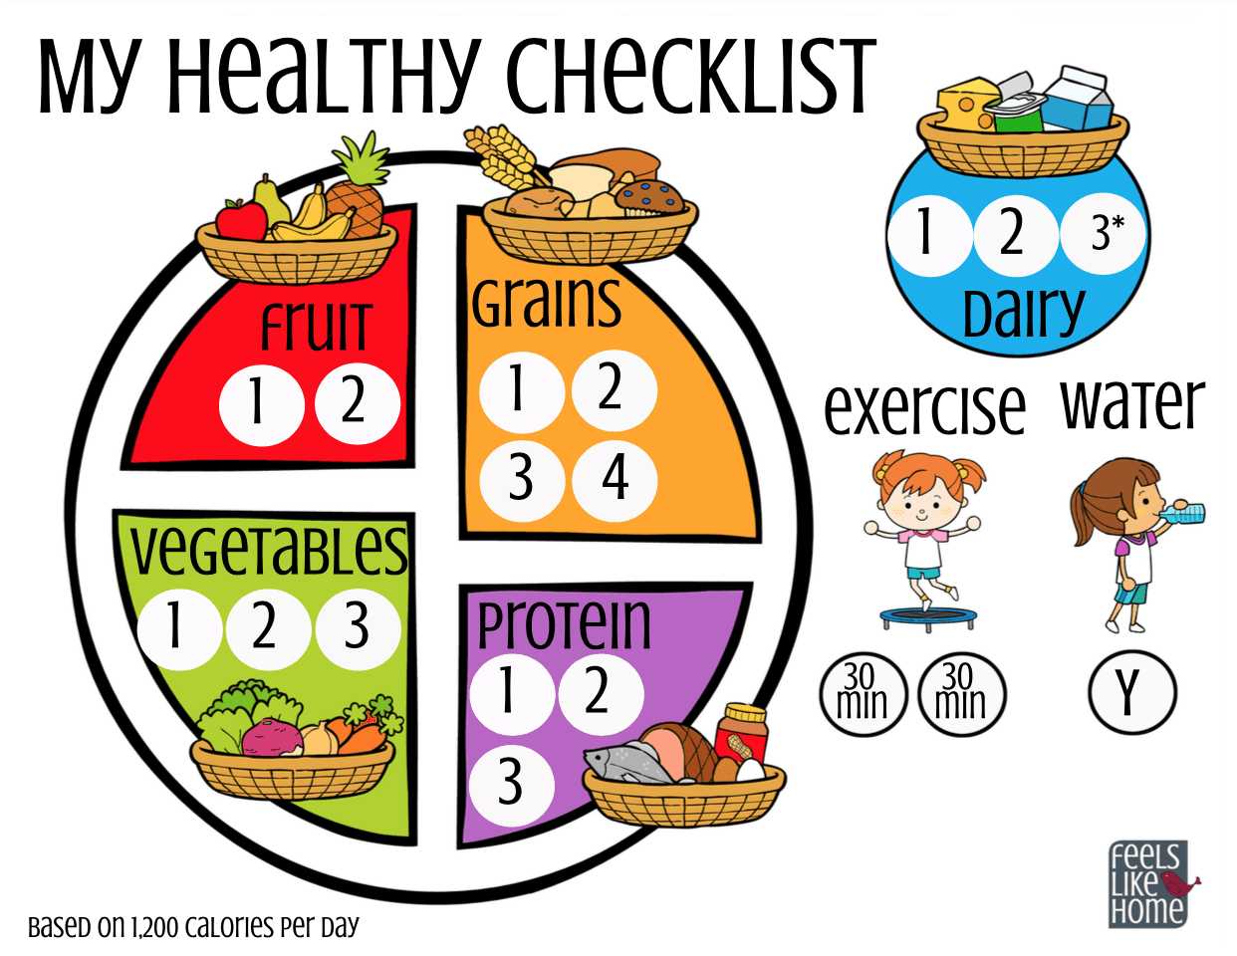
COVID-19 HEALTH AND SAFETY PLAN

The importance of staying home when sick cannot be emphasized enough. We encourage all students, parents, staff, and teachers to self-monitor for symptoms at home prior to leaving for school. This plan is subject to change based on AZ Department of Health recommendations.

Symptoms include:
- Fever (temperature 100.4 ºF or higher)
- Sore throat
- New uncontrolled cough that causes difficulty breathing (for a child with chronic allergic/asthmatic cough, see if there is a change from their usual cough)
- Diarrhea, vomiting, or stomachache
- New onset of headache, especially with a fever

Student health
- Children are required to wash their hands upon entering the classroom and before and after eating.
- Children who start to experience symptoms while at school will be brought to the preschool office and supervised until they can be picked up.
- Students may not return to the school until they have been fever free for 24 hours.
- Should the school receive information about a student testing positive for COVID 19 the health department will be notified, and all directives followed. This is the same protocol for other communicable diseases such as chicken pox, measles, etc. Information will be shared via email with all families as deemed appropriate by the health department.
- Students who test positive for COVID-19 may return to school 5 days after symptoms first appeared and 24 hours fever free without the use of medications and other symptoms of COVID-19 are improving.

Healthy environment
- Face coverings are optional for children and adults. This is subject to change for adults and will be communicated if a change of policy is deemed necessary.
- Each class will be limited to 12 students.
- Each class will be with the same group of children and staff each day.
- Supplies used in the classroom are cleaned between uses.
- Staff disinfect high-touch surfaces, such as door handles, light switches, faucets, toilet seats and handles routinely and at the end of the school day.

Contingency plan
Should a significant rise in the number of COVID 19 cases warrant a change of plan:
- Student daily check in and out will be moved to outdoor patio.
- Temperature and health question assessments upon arrival.
SICKNESS POLICY

Children who are ill must be kept at home. No child will be allowed to stay at school with visible signs of illness. Parents are required to notify the school whenever a child contracts a contagious disease (strep, measles, etc). We must keep records of these illnesses. If a child becomes ill at school, parents will be called. An isolation mat is provided for an ill child waiting transportation home. The staff will make every effort to keep this child comfortable.

We require that you keep your child at home with any of the following symptoms and/or illness:

*Fever greater than 100 *Runny Nose *Questionable rashes
*Coughing * Diarrhea *Conjunctivitis (Pink Eye)

If your child is being treated with antibiotics, he/she should be on the drug for at least 24 hours before returning to school.

If your child has a continually clear-runny nose or rash due to non-contagious allergies, please let us know. We realize that some symptoms hang on long after the child is no longer contagious. Remember, we want all our students to remain healthy and happy.
Please call us anytime your child is absent. (778-7049)
We must report all communicable diseases to the health department.

COMMON CHILDHOOD DISEASES
CHICKEN POX
Incubation Period: 12-21 days.
Contagious Period: Until crusts have fallen off and scars have healed.
Symptoms: Slight fever, headache, rash, and itching skin.

GERMAN MEASLES
Incubation Period: 12-21 days.
Contagious Period: Until three days after disappearance of rash.
Symptoms: Slight fever and rash (small, pink color; fades on pressure; appears like
blush).

MUMPS
Incubation Period: 12-16 days.
Contagious Period: Until swelling has completely disappeared.
Symptoms: Swelling and pain in salivary glands at sides of neck, difficulty in
swallowing, headache, and fever.

CONJUNCTIVITIS (PINK EYE)
Incubation Period: 24-72 hours after exposure to infected person or articles.
Contagious Period: Until infection is completely gone.
Symptoms: Itching and burning of the eyes, redness and tearing of the eyes, sensitivity to light, swollen eyelids, and a thick drainage that makes the eyelids stick together.

IMPETIGO
Incubation Period: 2-5 days
Contagious Period: Until a child has been on antibiotics for at least 24 hours.
Symptoms: Flat, yellow, crusty, or weeping patch on the skin usually around the nose and mouth. It usually starts as tiny blister that break and leave the skin red and moist.
AMERICAN LUTHERAN SCHOOL FINANCIAL POLICIES
- Our school is a non-profit and self-supporting institution. Tuition is paid as a monthly flat fee.
- All payments are made to American Lutheran School by check, cashier’s check, or money order.
- All payments are due on the first day of the month.
- Payments not received by the tenth of the month will have a 5% late fee added.
- A 10% discount is given for full yearly tuition paid in one payment by August 1st.
- A 10% discount will be given to members of American Lutheran Church.
- The maximum discount allowed will be 10%.
- All checks returned by the bank will have a $25.00 service charge.
- Tuition is divided into 9 equal payments. The first payment is due August 1st. Tuition payments are due the first of each month August through April. Credit is not given for days missed or months with holiday or vacation days.
- Campus closures:
  - Should officials close school campuses before Christmas break, the school year will be suspended. All pre-paid tuition will be fully refunded. American Lutheran School will reopen when officials deem it appropriate.
  - Should officials close campuses prior to spring break, but after Christmas break, remote learning will be offered for an additional month. Refunds will be made after 1 month’s closure.
  - If the closure comes after spring break, remote learning will be implemented through the end of the school year. Families have the option of; 1 - continuing the remote learning and paying tuition on the regular schedule or 2 - withdrawing their student for the remainder of the school year and discontinuing tuition payments.
- If an account becomes more than one month past due, the child may be excluded from school until the account is paid. This action may void an available space for the child’s return.
- A limited budget demands that the school operates on a full capacity level, thus two weeks
written notice must be given if your child is to be withdrawn from the school. If this notice is not given, you will be charged two weeks’ tuition. No refunds of tuition paid will be made on withdrawals after May 1st.
Hardship cases are reviewed on an individual basis.
- All tuition is due on the first of the month. Schedule for contacting delinquencies:
- Delinquent after the 10th, 5% late fee added
- Check in message or email reminder – 5th
- Email or phone call – 11th
- Second reminder letter or phone call – 15th
- “No return” letter – 20th
- Children not picked up by 11:40 will be charged the “lunch bunch” fee of $10.00.
- Partial scholarships are available for families with financial need. A scholarship application
must be completed. Scholarship forms are available from the school office.
The Director will notify you of the decision of the Scholarship Committee.
- Extended Care fees are as follows and must be paid prior to care:
- Early Bird (morning childcare) 8:00 am – 8:30 am = $5/day
- Lunch Bunch 11:30 am – 1:00 pm = $10/day
- A late fee of $10 will be charged for students not picked up by 1:00 pm.

MONTHLY TUITION FEES:
Class | Monthly | ALC  Members | Yearly Tuition | Full Tuition with 10% discount
Pre K (5 day) | $350.00 | $315.00 | $3150.00 | $2835.00
M-W-F (3 day) | $265.00 | $238.50 | $2385.00 | $2146.50
T-Th (2 day) | $200.00 | $180.00 | $1800.00 | $1620.00

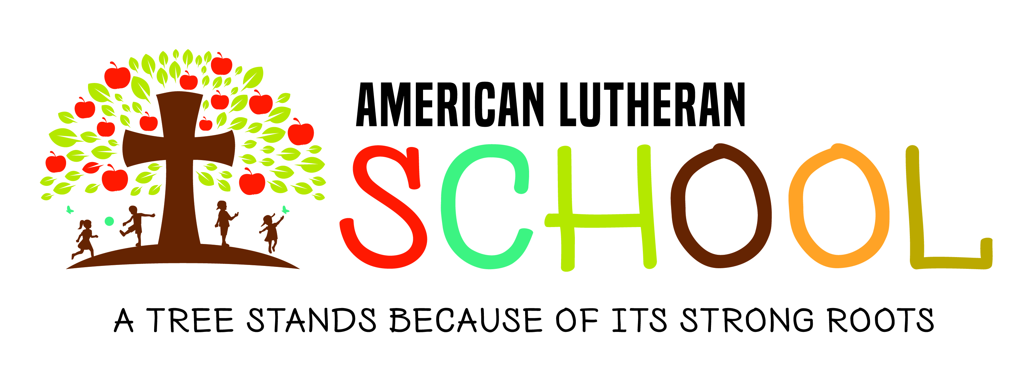

2022-2023
American Lutheran School Calendar
(SUBJECT TO CHANGE)
September
6 T FIRST DAY OF SCHOOL
14-28 Annual Flower Bulb Sale Fundraiser
22 TH Picture Day Mrs. Garber’s and Mrs. Huard’s Classes
23 F Picture Day Miss Hall’s / Mrs. Snyder’s / Mrs. DuBord’s Classes

October
10-14 M-F Fall Break – NO SCHOOL
20 TH Pumpkin Patch Mrs. Garber’s and Mrs. Huard’s Classes
21 F Pumpkin Patch Miss Hall’s / Mrs. Snyder’s / Mrs. DuBord’s Classes
26 W 5:30 pm Pumpkin Carving w/Dad
27 TH Costume Parade/Party – 2 day classes
31 M Costume Parade/Party – 3 day and Pre K classes

November
1 – 15 Operation Christmas Child Service Project
11 F Veteran’s Day Holiday – NO SCHOOL
23-25 W-F Thanksgiving Break – NO SCHOOL

December
7 W 5:30 pm Christmas Craft Night
14 W 10:30 am All School Christmas Program - NO LUNCH BUNCH
22-1/4 Christmas Break – NO SCHOOL

January
1-4 Christmas Break – NO SCHOOL
16 M Martin Luther King Holiday – NO SCHOOL

February
7-10 T-F Parent/Teacher Conference days– NO LUNCH BUNCH
13 M Classroom Valentine Parties – 3 day classes
14 T Classroom Valentine Parties – 2 day and Pre k Classes
17-20 F & M President’s Day Holiday– NO SCHOOL
24 F 5:30 pm Family Movie Night

March
13-17 M-F Spring Break – NO SCHOOL
24 F 10:30 am Nursery Rhyme Theater - All classes - NO LUNCH BUNCH
April
5 W Egg Hunts– Miss Hall’s / Mrs. Snyder’s / Mrs. DuBord’s Classes
6 TH Egg Hunts - Mrs. Garber’s and Mrs. Huard’s Classes
7 - 10 F & M Good Friday and Easter Holiday - NO SCHOOL

May Celebrate Summer Birthdays
11 TH 10:30 am Mother’s Day Tea – 2 day and Pre K classes
12 F 10:30 am Mother’s Day Tea – 3 day classes
19 F 10:30 am ALS Graduation – NO LUNCH BUNCH
25 TH LAST DAY OF SCHOOL - No Lunch Bunch


Signature Page
Please fill out and return to preschool office.

I have read, understood, and agree to abide by the American Lutheran School Handbook as it pertains to: Programs, Rules, Admission Requirements, and Procedures.

I give permission for my child's picture to be included on the school website and Facebook page.

I give permission for my child to participate in class activities on the grass area in front of the preschool.

I give permission for American Lutheran School staff to sign my student in and out each day as needed.

Child(ren) ____________________________________________________

Guardian Name (Please Print) ___________________________________

Signature ___________________________________Date______________

